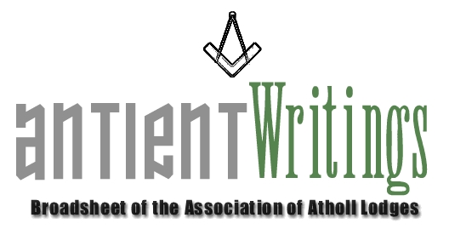

3rd Edition, 2006

Dermott 2006 – CANCELLATION of the London Event

SAT JULY 22ND 2006….. London Event - Displays & Luncheon - Gt Queen Steet

This summer event was cancelled due to lack of support – see below for revised event

Dermott 2006 – Other Events

If you are able to get to Stockport there will be a Dermott event held there on Sat 23rd September, starting at 11am. Details: Clive Ball, 46 Woods Lane, Dobcross, Oldham, OL3 5AN, on 01457 871317. clive@dobx46.freeserve.co.uk

There will also be a ‘Dermott Visit’ to the Gillingham Lodge of Benevolence No. 184 on Tuesday 10th October. The Lodge Secretary will be pleased to hear from you if you would like to attend.

REVISED LONDON EVENT – Will now take place at the Lion and Lamb’s regular meeting on Wednesday 4th October at Great Queen Street, London, starting at 3.45pm. A Flyer with booking details is on the reverse of this broadsheet.
If every Atholl lodge could be represented this will be a memorable event. Invite you friends to this WHITE TABLE!

A Brothers Assistant – The Laurence Dermott Story

A special 40 page illustrated book is available, telling the story of Laurence Dermott. They will be available at the various events throughout the year. But if you would like a copy please contact the Secretary. They are £6 inc P & P.

Annual General Meeting

The 2006 Annual General Meeting was held at FM Hall Great Queen Street London on Wed 5th July. The significant change adopted was to amend the constitution to permit Chapters and Concomitant Degrees with Atholl heritages to become subscribing members. Clearly RA and Mark and KT were operating degrees under an Antient’s warrant and those extant [albeit in a different guise] are most welcome into the Atholl family. Details on the web-site. The meeting also recorded with sadness the death of Wally Hall, the founder and ‘father’, of the Association.

New Hope – Rescue a Lodge

If you are a struggling Atholl lodge bereft of members and looking the stark reality of erasure in the face – don’t despair. The Secretary is aware of a group of ‘Atholl’ enthusiasts who are willing to ‘resue’ such a lodge rather than let it be lost. The plan would be to enrich its membership and move it to Sindlesham, Berkshire where it would have a safe and secure home [and future]. Further information available through a link contact.

St Andrews No.231 Celebration

St Andrews will celebrate 250 years of continuous working on Thursday 30th November 2006 [St Andrew’s Day] in London. The Lodge Secretary would like to hear from any brother who might like to attend. [01296 623433]

Help Required

If you are interested in joining the Executive Committee, which meets 3 times a year in London with the possibility in future of having one meeting out of London,, maybe in the Midlands. Please make contact with the Secretary who is always keen to involve new blood and share common antient interests with Atholl brethren.

Would Secretaries and Representatives photocopy and distribute as widely as possible

Paul Gardner - 39 Wentworth Drive, Bedford, BEDS, MK41 8QA - 01234 261584 - secretary@antients.com

